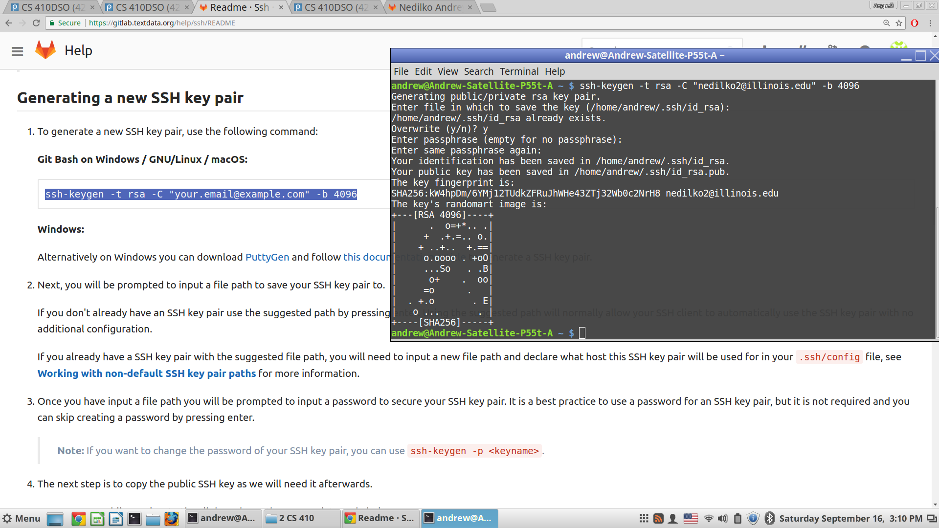
Generating SSH key pair for Cloning GitLab on Local Machine

https://gitlab.textdata.org/help/ssh/README

SSH

Git is a distributed version control system, which means you can work locally but you can also share or "push" your changes to other servers. Before you can push your changes to a GitLab server you need a secure communication channel for sharing information.

The SSH protocol provides this security and allows you to authenticate to the GitLab remote server without supplying your username or password each time. For a more detailed explanation of how the SSH protocol works, we advise you to read this nice tutorial by DigitalOcean.

Locating an existing SSH key pair

Before generating a new SSH key pair check if your system already has one at the default location by opening a shell, or Command Prompt on Windows, and running the following command:

Windows Command Prompt:
type %userprofile%\.ssh\id_rsa.pub

Git Bash on Windows / GNU/Linux / macOS / PowerShell:
cat ~/.ssh/id_rsa.pub

If you see a string starting with ssh-rsa you already have an SSH key pair and you can skip the generate portion of the next section and skip to the copy to clipboard step. If you don't see the string or would like to generate a SSH key pair with a custom name continue onto the next step.

Note: Public SSH key may also be named as follows:
id_dsa.pub
id_ecdsa.pub
id_ed25519.pub

Generating a new SSH key pair

To generate a new SSH key pair, use the following command:

Git Bash on Windows / GNU/Linux / macOS:

ssh-keygen -t rsa -C "your.email@example.com" -b 4096

Windows:
Alternatively on Windows you can download PuttyGen and follow this documentation article to generate a SSH key pair.

Next, you will be prompted to input a file path to save your SSH key pair to.

If you don't already have an SSH key pair use the suggested path by pressing
enter. Using the suggested path will normally allow your SSH client
to automatically use the SSH key pair with no additional configuration.

If you already have a SSH key pair with the suggested file path, you will need
to input a new file path and declare what host this SSH key pair will be used
for in your .ssh/config file, see Working with non-default SSH key pair paths
for more information.

Once you have input a file path you will be prompted to input a password to
secure your SSH key pair. It is a best practice to use a password for an SSH
key pair, but it is not required and you can skip creating a password by
pressing enter.

Note:
If you want to change the password of your SSH key pair, you can use ssh-keygen -p <keyname>.

The next step is to copy the public SSH key as we will need it afterwards.

To copy your public SSH key to the clipboard, use the appropriate code below:

macOS:
pbcopy < ~/.ssh/id_rsa.pub

GNU/Linux (requires the xclip package):
xclip -sel clip < ~/.ssh/id_rsa.pub
Windows Command Line:
type %userprofile%\.ssh\id_rsa.pub | clip

Git Bash on Windows / Windows PowerShell:
cat ~/.ssh/id_rsa.pub | clip

The final step is to add your public SSH key to GitLab.

Navigate to the 'SSH Keys' tab in your 'Profile Settings'. Paste your key in the 'Key' section and give it a relevant 'Title'. Use an identifiable title like 'Work Laptop - Windows 7' or 'Home MacBook Pro 15'.

If you manually copied your public SSH key make sure you copied the entire key starting with ssh-rsa and ending with your email.

Optionally you can test your setup by running ssh -T git@example.com (replacing example.com with your GitLab domain) and verifying that you receive a Welcome to GitLab message.

Working with non-default SSH key pair paths

If you used a non-default file path for your GitLab SSH key pair, you must configure your SSH client to find your GitLab private SSH key for connections to your GitLab server (perhaps gitlab.com).

For your current terminal session you can do so using the following commands (replacing other_id_rsa with your private SSH key):

Git Bash on Windows / GNU/Linux / macOS:
eval $(ssh-agent -s)
ssh-add ~/.ssh/other_id_rsa

To retain these settings you'll need to save them to a configuration file. For OpenSSH clients this is configured in the ~/.ssh/config file for some operating systems. Below are two example host configurations using their own SSH key:

# GitLab.com server
Host gitlab.com
RSAAuthentication yes
IdentityFile ~/.ssh/config/private-key-filename-01

# Private GitLab server
Host gitlab.company.com
RSAAuthentication yes
IdentityFile ~/.ssh/config/private-key-filename

Due to the wide variety of SSH clients and their very large number of
configuration options, further explanation of these topics is beyond the scope
of this document.

Public SSH keys need to be unique, as they will bind to your account.
Your SSH key is the only identifier you'll have when pushing code via SSH.
That's why it needs to uniquely map to a single user.

Deploy keys

Deploy keys allow read-only or read-write (if enabled) access to one or
multiple projects with a single SSH key pair.

This is really useful for cloning repositories to your Continuous Integration (CI) server. By using deploy keys, you don't have to setup a dummy user account.

If you are a project master or owner, you can add a deploy key in the project settings under the section 'Repository'. Specify a title for the new deploy key and paste a public SSH key. After this, the machine that uses the corresponding private SSH key has read-only or read-write (if enabled) access to the project.

You can't add the same deploy key twice using the form. If you want to add the same key to another project, please enable it in the list that says 'Deploy keys from projects available to you'. All the deploy keys of all the projects you have access to are available. This project access can happen through being a direct member of the project, or through a group.

Deploy keys can be shared between projects, you just need to add them to each project.

Applications

Eclipse

How to add your SSH key to Eclipse: https://wiki.eclipse.org/EGit/User_Guide#Eclipse_SSH_Configuration

Troubleshooting

If on Git clone you are prompted for a password like git@gitlab.com's password:
something is wrong with your SSH setup.

Ensure that you generated your SSH key pair correctly and added the public SSH key to your GitLab profile
Try manually registering your private SSH key using ssh-agent as documented earlier in this document
Try to debug the connection by running ssh -Tv git@example.com (replacing example.com with your GitLab domain)

